PROJECT TITLE:
Automated Linux Setup Script Generator
K.SRIHARIREDDY SHASHIDHAR
CYBER SECURITY CYBER SECURITY TRAINER
TAH2706251671 TEKS ACADEMY
TEKS ACADEMY 9603343287
8074607263

Abstract:
In modern system administration, writing configuration scripts is a repetitive but critical task. Administrators often need to create and manage users, groups, permissions, and firewall rules across multiple systems. Manual script writing is prone to human error, time-consuming, and lacks consistency.
The *Automated Script Generator* addresses this challenge by providing a tool where users can input their requirements through a simple interface. Based on these inputs, the system automatically generates a complete configuration script (e.g., Bash, PowerShell, or Ansible). This reduces manual workload, improves reliability, and ensures standardization across environments.
Problem Statement:
System administrators often spend a significant amount of time writing and validating configuration scripts for setting up servers. For example:

* Creating multiple user accounts
* Defining groups and assigning permissions
* Configuring firewall rules for security
* Reusing scripts across different servers

Errors in these scripts can lead to misconfigurations, security loopholes, or downtime. The lack of automation increases the chance of mistakes and delays. Therefore, there is a need for a system that can automatically generate configuration scripts based on user-defined requirements..
Project Objective(s):
- * Provide a *user-friendly interface* for defining requirements.
- * Generate accurate and *ready-to-use configuration scripts*.
- * Support multiple script formats (Linux Bash, Windows PowerShell, Ansible YAML).
- * Reduce time and effort for system administrators.
- * Ensure consistency and eliminate human error in configurations.

Project Scope:
* ✅ *Included*:

* User management (add/remove users, assign groups)
* Group management
* Firewall rule configuration
* Script validation & preview
* Export in .sh, .ps1, .yaml formats

* ❌ *Excluded*:

* Real-time deployment of scripts on servers
* Cloud platform automation (AWS, Azure, GCP) in this version
* Monitoring or auto-healing of services
🛠️ Tools & Technologies:

- *Frontend:* React.js / HTML / CSS / TailwindCSS
- * *Backend:* Node.js with Express OR Python Flask/Django
- * *Script Engine:* Template-based generator (Jinja2 / Handlebars.js)
- * *Database:* SQLite / MongoDB for saving templates & history
- * *Platform:* Linux (for execution/testing)

Timeline (Tentative):
Week Task
DAY 1 Research user requirements and finalize system design
DAY 2 Develop input form (Users, Groups, Firewall rules)
DAY 3 Implement backend script generator logic
DAY 4 Add script validation & export feature
DAY 5 Testing, documentation, and final demo

Deliverables:

* A web application for script generation
* Auto-generated configuration scripts (.sh, .ps1, .yaml)
* Template saving & loading feature
* Documentation and project report
* Final presentation/demo

Project implementation:

Step 1: Install required dependencies (Node.js/Python, Database)
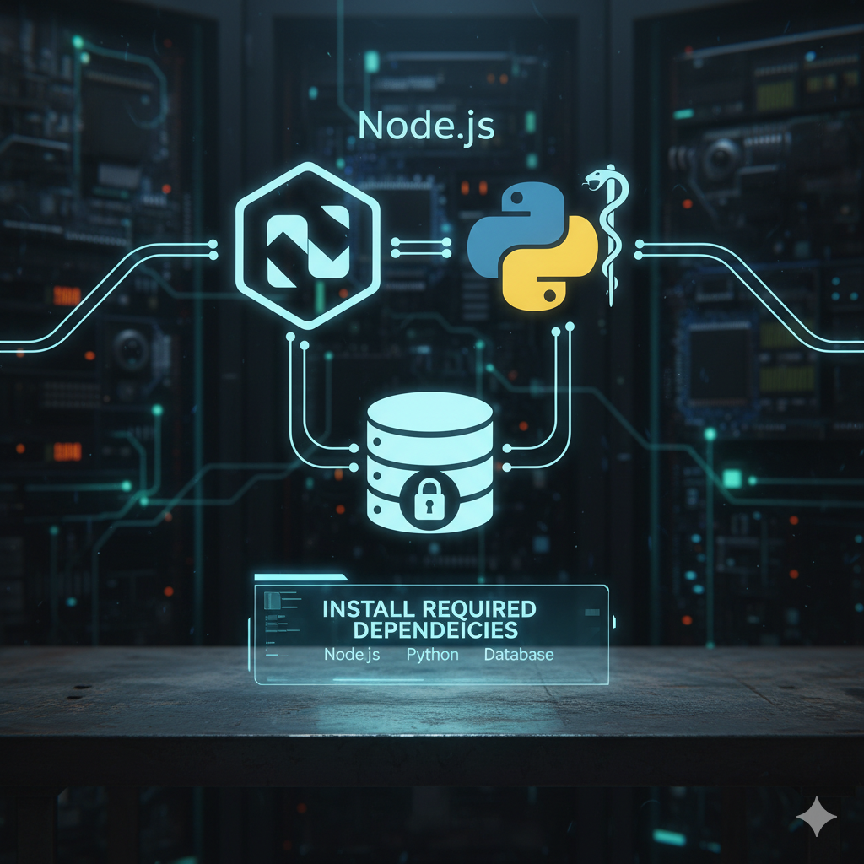

Step 2: Develop the frontend for user input
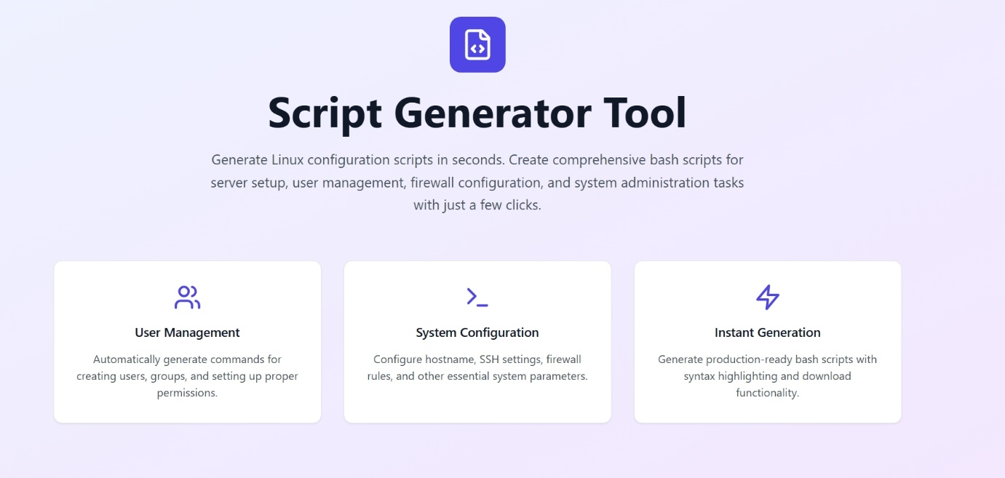

Step 3: Implement backend parser & script generation engine
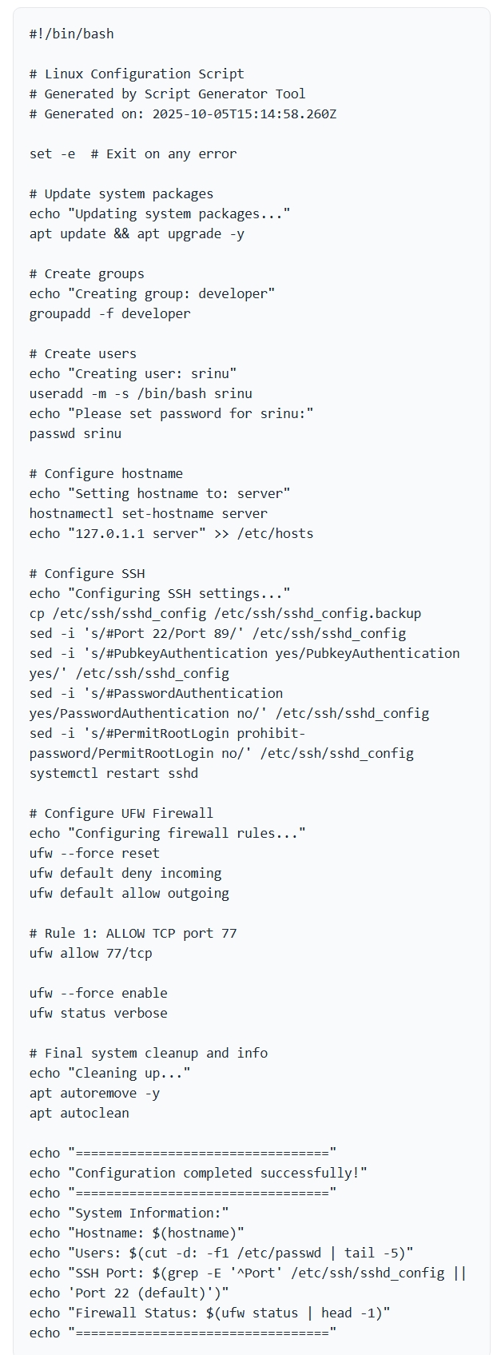

Step 4: Add validation for user inputs
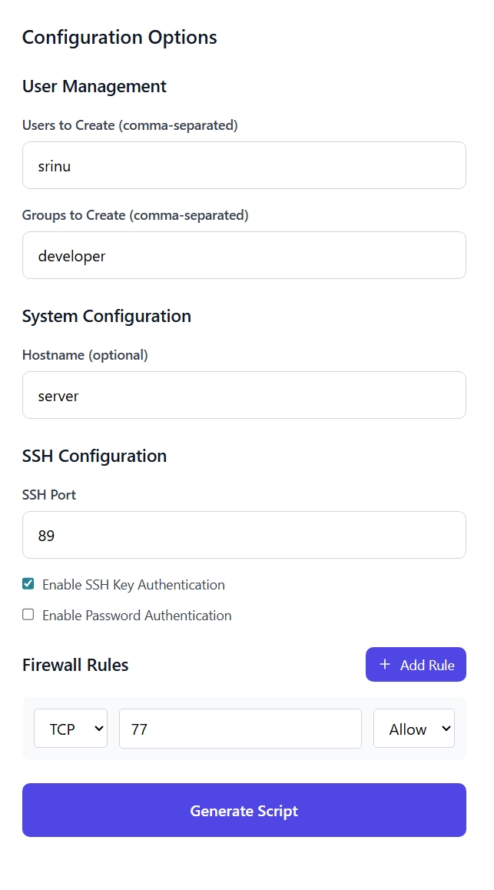

Step 5: Enable script preview & download functionality

Step 6: Test with sample scenarios (users, groups, firewall rules)

Step 7: Finalize documentation and demo

## Example Generated Script (Linux Bash)

*Input:*

* Users: admin, developer
* Groups: dev-team
* Firewall: Allow port 22, deny port 23

*Output Script:*

bash
#!/bin/bash

# Create users
useradd admin
useradd developer

# Create group and assign users
groupadd dev-team
usermod -aG dev-team admin
usermod -aG dev-team developer

# Configure firewall
ufw allow 22/tcp
ufw deny 23/tcp

## Frontend Implementation

The frontend will be built using *React.js*, ensuring a modern, responsive, and easy-to-use interface.

* Input fields for users, groups, and firewall rules.
* Buttons for *Preview Script, **Download Script, **Save Template*.
* Real-time preview of the generated script.
* Styled using TailwindCSS/Bootstrap for a clean UI.

Conclusion

The Automated Script Generator project provides a practical and efficient solution for system administrators and IT professionals who need to create configuration scripts quickly and accurately. By automating the process of generating scripts for user management, group assignments, and firewall configurations, the tool reduces manual effort, minimizes errors, and ensures consistency across multiple systems.

This project demonstrates how automation can save time, improve reliability, and standardize administrative tasks that are otherwise repetitive and error-prone. With its simple yet effective design, the Script Generator can serve as a foundation for future enhancements such as cloud integration, multi-server deployment, and support for advanced configurations.

In conclusion, the project successfully achieves its objectives by offering a user-friendly, reliable, and extendable solution that simplifies configuration management in both academic and real-world environments.

